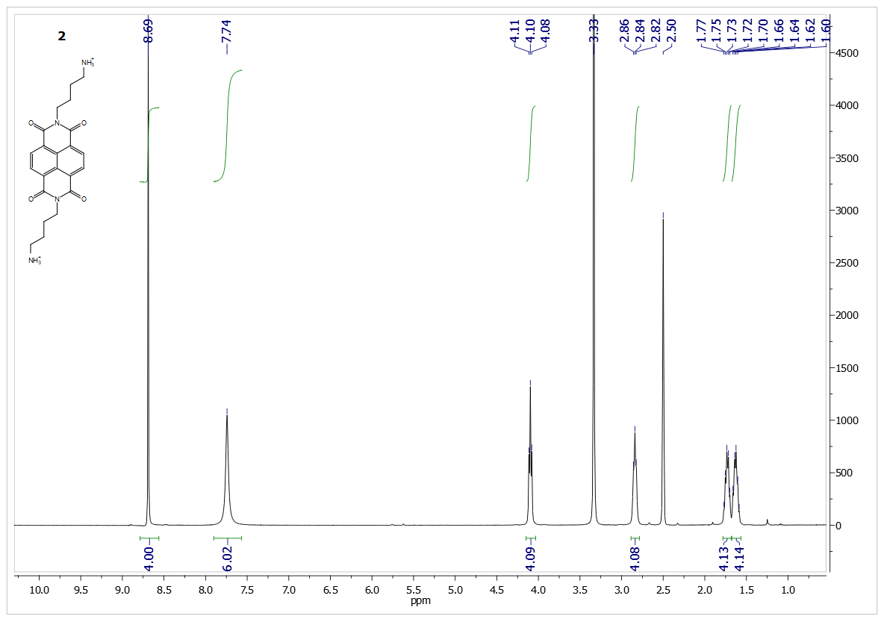
Figure 1. Compound 2. ¹H NMR (400 MHz, DMSO) δ(ppm): 8.69 (s, 4H), 7.74 (s, 6H), 4.10 (t, J = 6.7 Hz, 4H), 2.84 (t, J = 6.5 Hz, 4H), 1.79 – 1.68 (m, 4H), 1.62 (dt, J = 15.0, 7.4 Hz, 4H).
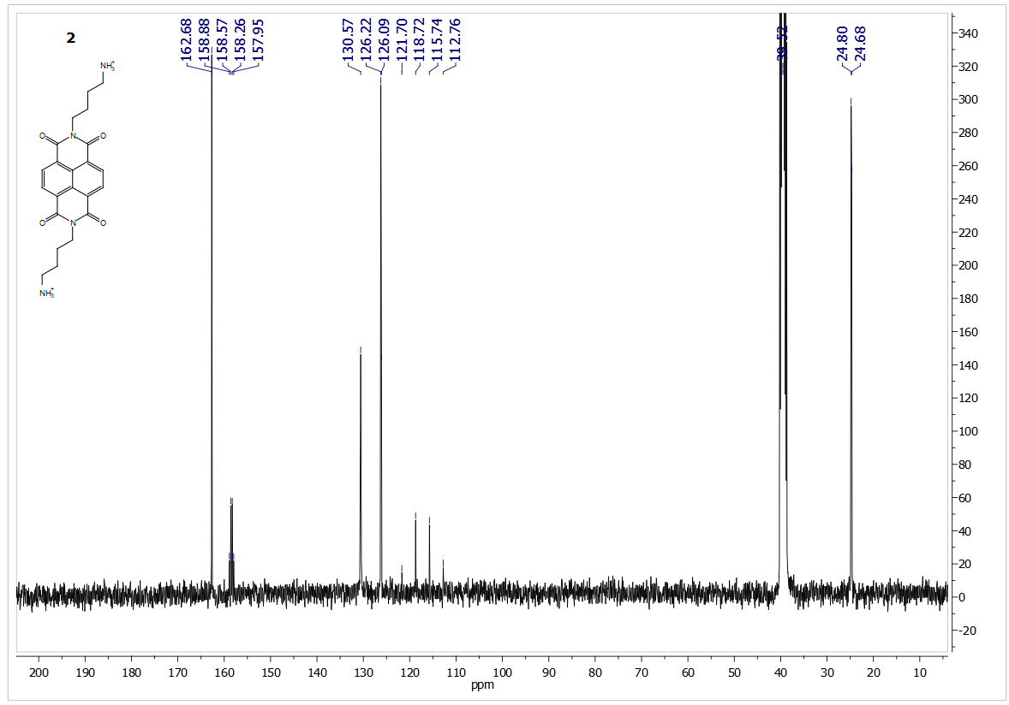
Figure 2. Compound 2. ¹³C NMR (101 MHz, DMSO) δ (ppm): 162.68, 158.88, 158.57, 158.26, 157.95, 130.57, 126.22, 126.09, 121.70, 118.72, 115.74, 112.76, 39.52, 24.80, 24.68
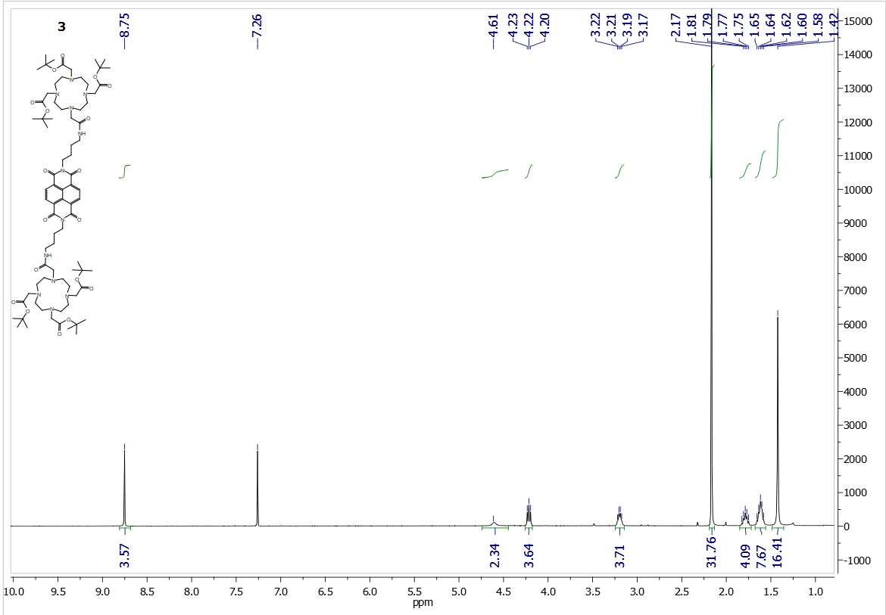
Figure 3a. Compound 3. 1H NMR (400 MHz, CDCl₃) δ 8.75 (s, 4H), 4.61 (s, 2H), 4.21 (t, J = 7.4 Hz, 4H), 3.20 (dd, J = 12.5, 6.2 Hz, 4H), 2.17 (s, 32H), 1.79 (dt, J = 15.2, 7.7 Hz, 4H), 1.68 – 1.56 (m, 8H), 1.42 (s, 16H).
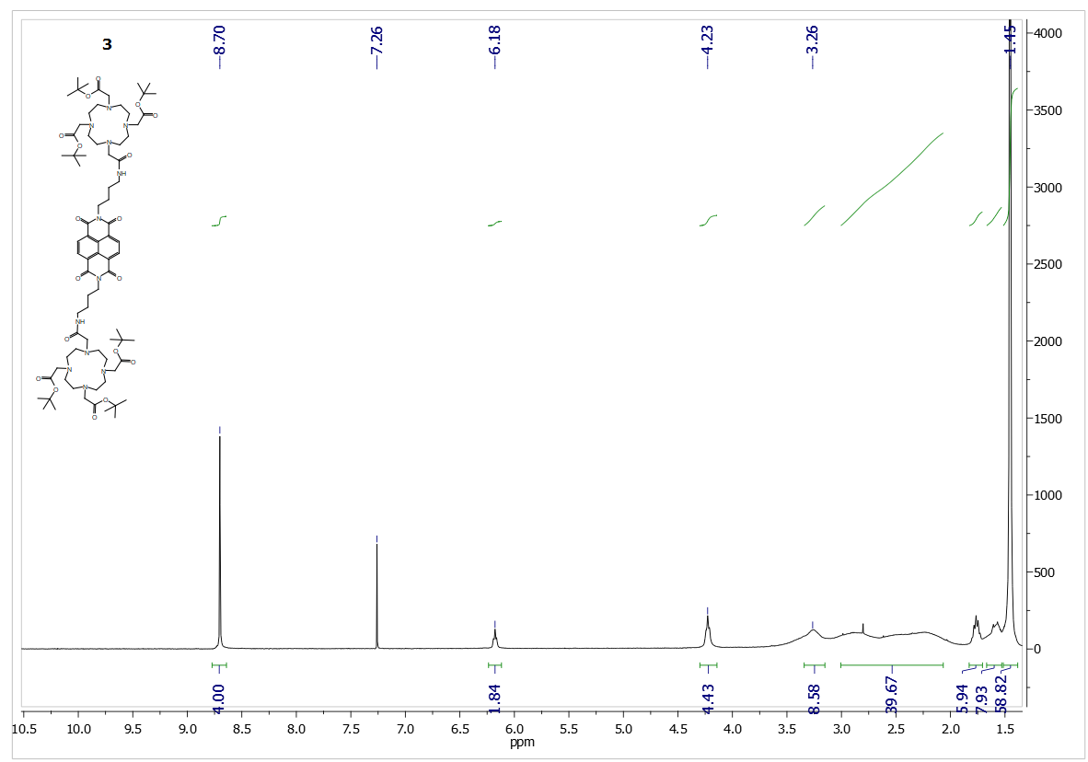
Figure 4b. Compound 3. 1H NMR (400 MHz, CDCl3) δ 8.70 (s, 4H), 6.18 (t, J = 5.6 Hz, 2H), 4.23 (t, J = 6.2 Hz, 4H), 3.26 (s, 8H), 2.54 (s, 40H), 1.83 – 1.71 (m, 6H), 1.59 (d, J = 14.9 Hz, 8H), 1.45 (d, J = 3.2 Hz, 58H. A drop of methanol-d4 was added.
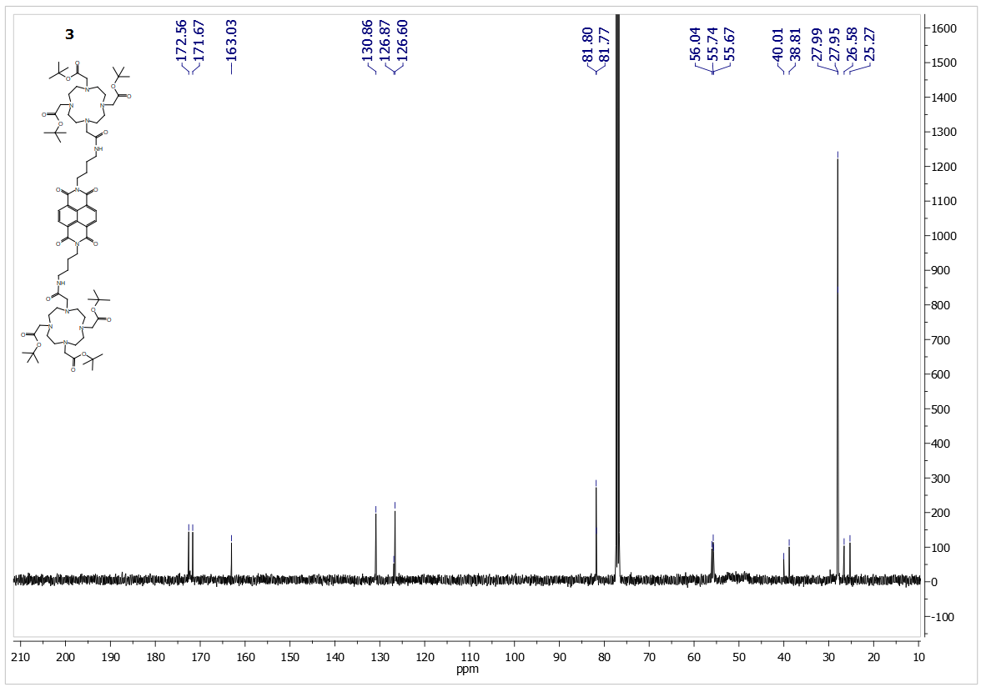
Figure 5. Compound 3. ¹³C NMR (101 MHz, CDCl₃) δ 172.56, 171.67, 163.03, 130.86, 126.87, 126.60, 81.80, 81.77, 56.04, 55.74, 55.67, 40.01, 38.81, 27.99, 27.95, 26.58, 25.27.

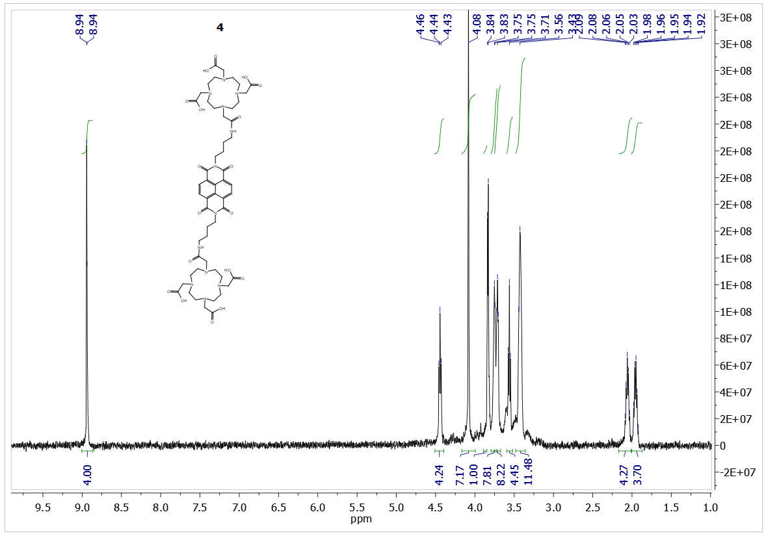
Figure 6. Compound 4. 1H NMR (500 MHz, D₂O, 343 K) δ (ppm): 8.94 (d, J = 2.6 Hz, 4H), 4.44 (t, J = 7.4 Hz, 4H), 4.08 (s, 8H), 3.83 (s, 4H), 3.73 (t, J = 3.3 Hz, 8H), 3.71 (t, J = 3.3 Hz, 8H), 3.56 (t, J = 6.9 Hz, 4H), 3.43 (d, J = 7.6 Hz, 16H), 2.14 – 2.01 (m, 4H), 1.95 (dt, J = 14.2, 7.1 Hz, 4H).
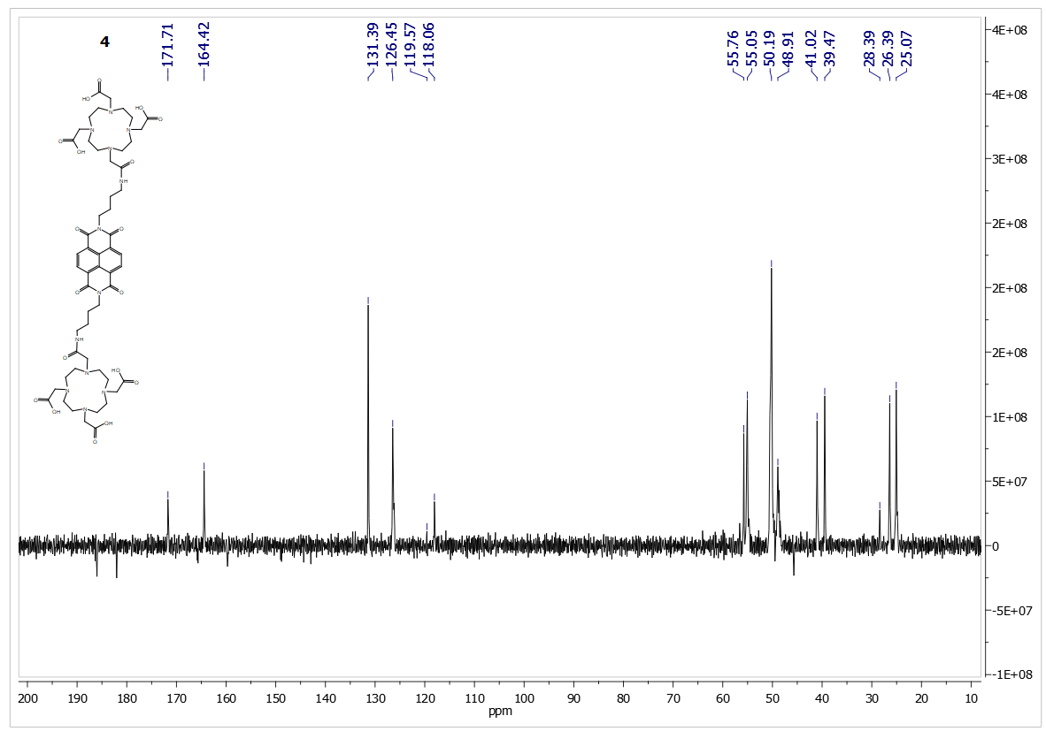
Figure 7. Compound 4. ¹³C NMR (101 MHz, D2O, 343 K) δ (ppm): 171.71, 164.42, 131.39, 126.45, 119.57, 118.06, 55.76, 55.05, 50.19, 48.91, 41.02, 39.47, 28.39, 26.39, 25.07.

